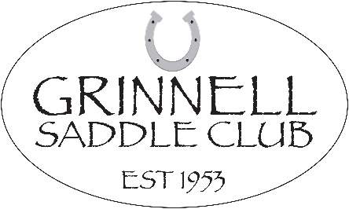
Friends of The Grinnell Saddle Club,

After a difficult 2020, we are feeling thankful and optimistic for the chance to gather with fellow horse enthusiasts again. The Grinnell Saddle Club has been the foundation of the equine community in Poweshiek County and surrounding areas for over sixty years. Each year we continue to strive to provide quality open shows for riders of all abilities and ages. We hope to provide a positive climate for horse owners and their families to enjoy their equine companions. In addition to serving our exhibitors, we are also dedicated to giving back to those in our community that need it most. Included on our show bill, we offer a charity class where all the proceeds go to a deserving cause, voted on and approved by our board.

This year we will be hosting 4 horse shows. It is with the help of our generous sponsors that our shows continue to be so successful. Please consider making a tax-deductible donation to help continue providing the same outstanding show experience year after year. All the monies we receive from sponsorships go directly to our exhibitors as their winnings and are not used in the form of operating costs.

Sponsorship is a great way to promote your business and your community. All sponsors will be recognized for their donations with the following:
- Business name or logo printed on our show bills
- Business name announced throughout the duration of our shows
- Business name or logo advertised on our Facebook page and website

Wondering how to become a sponsor? It’s simple! Visit our website www.grinnellsaddleclub.com, scroll to the bottom of the page, and click the DONATE button. Be sure to send us a copy of your business name and/or logo to: grinnellsaddleclub@gmail.com.
You may also fill out the attached sponsorship document and send a check to our treasurer:

Kelly Birkenholtz
440 N 59th Ave W
Newton, IA 50208

Please have all sponsorships completed by May 24th, so we can showcase your business! We invite you to check us out by visiting our Facebook page, our website, or attending one of our shows! We thank you in advance for considering becoming a GSC sponsor and helping to continue our long history of providing excellent horse shows in Central Iowa!

Officers
Shelly Nikkel-President
Heather Maas-Vice President
Martha Loney-Secretary
Kelly Birkenholtz-Treasurer

